**#1** (10 Points)

**Is the following function a proper distance function? Why? Explain your answer.**



**Hint: Measure the distance between (0,0), (0,1) and (1,1)**

**Solution:**

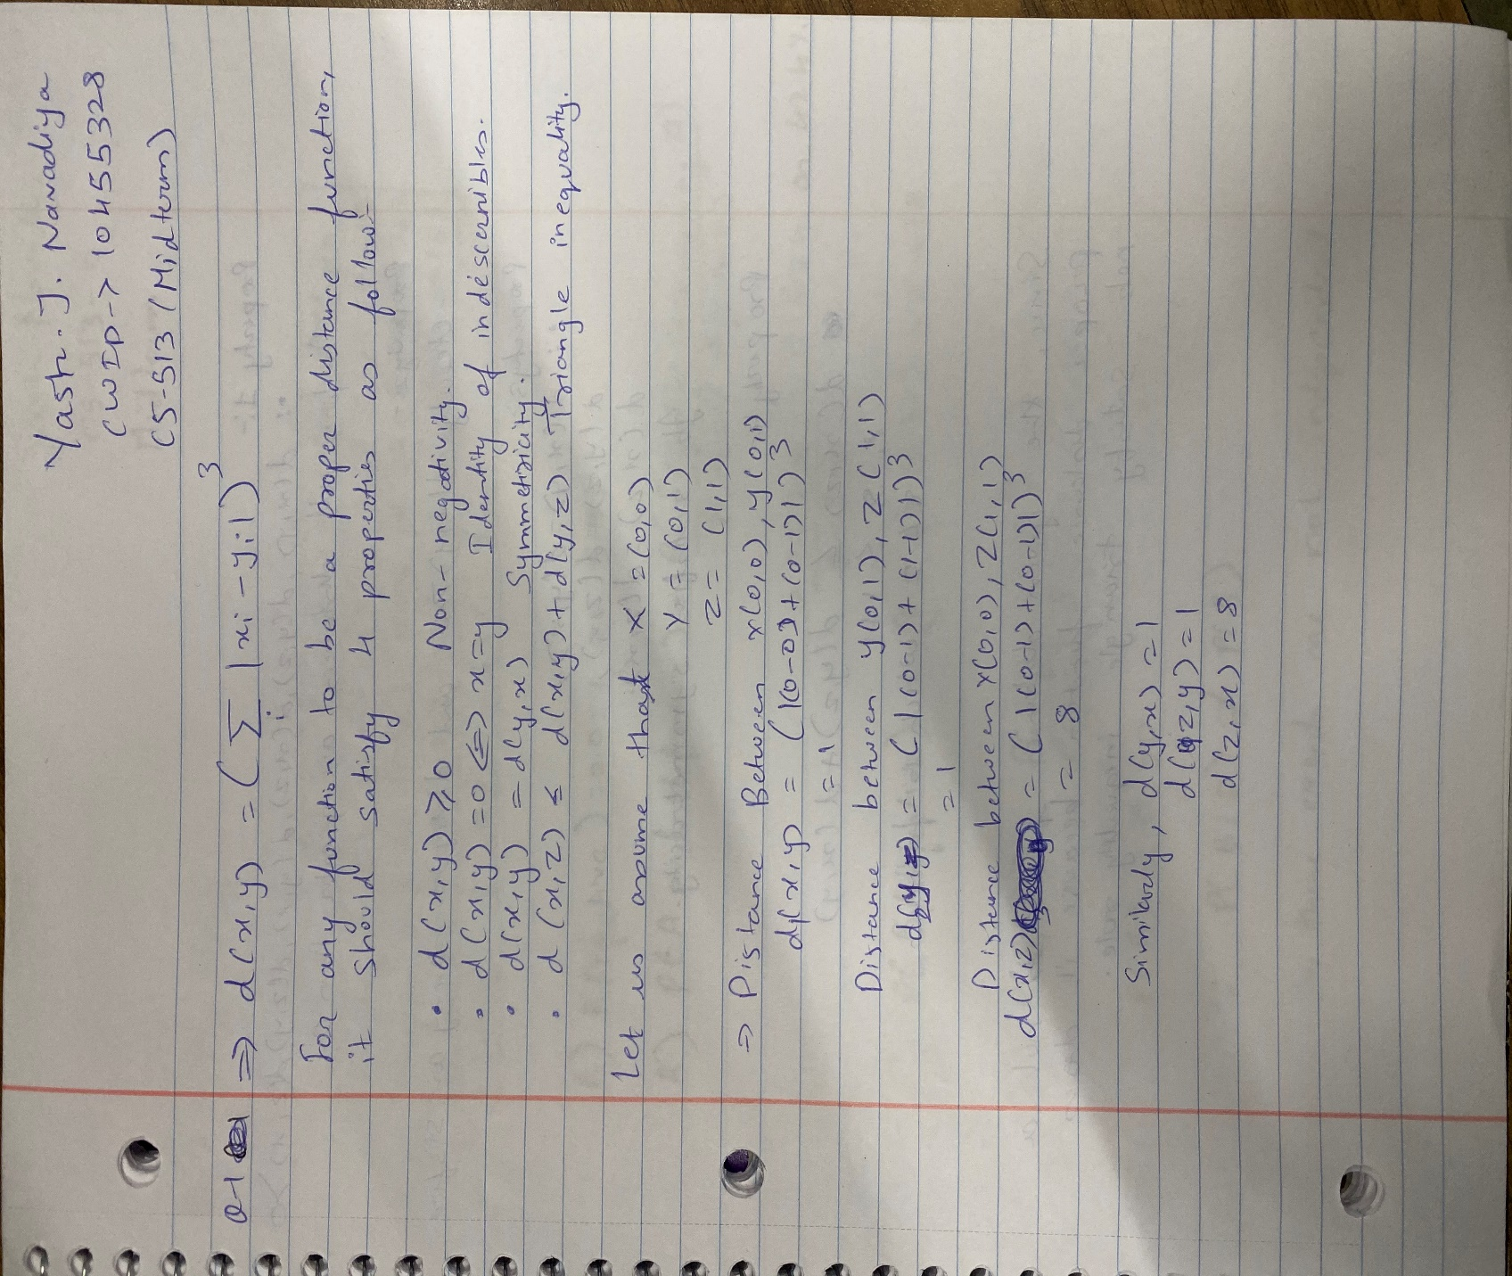

**# 2** (10 Points)

**There are three major manufacturing companies that make a product: Manufacturers A, B, and C. Manufacture A has a 50% market share, and Manufacture B has a 30% market share. 5% of A’s products are defective, 6% of B’s products are defective, and 8% of C’s products are defective.**

1. What is the probability that a randomly selected product is defective? P(Defective)?
2. What is the probability that a randomly selected product is defective and that it came from A? P(A and Defective)?
3. What is the probability that a defective product came from B? P(B/Defective)?
4. Are these events (being defective and coming from B) independent? Why?

